APPENDIX M6
DISPOSAL DELIVERY FORM
[PS Clause 25.25S]

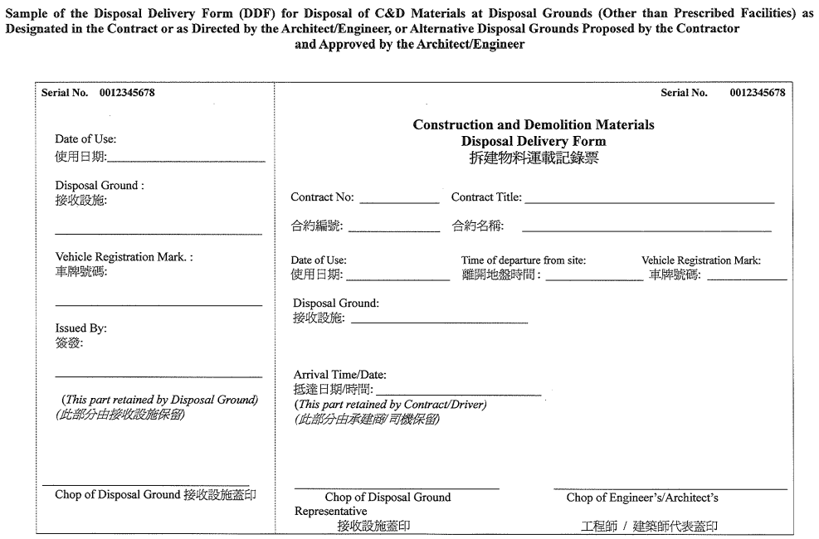

[BLANK PAGE]

